Answers to H2 Chemistry Preliminary Examinations 2009 Paper 3

1 | (a) | - AlF₃ exists as giant ionic lattice with strong ionic bonds between the ions. Large amount of energy of energy is required to overcome the strong electrostatic attraction between oppositely charged ions and hence, a high melting point.  - AlCl₃ exists as a simple molecular structure. Melting involves overcoming the weak Van der Waals forces of attraction. Little energy is required to overcome the intermolecular forces of attraction and thus, AlCl₃ has a lower melting point as compared to NaCl.
 | (b) | (i) | - High C:H ratio infers that P is an aromatic compound.  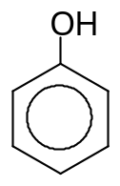  P  - With anhydrous aluminium chloride P undergoes electrophilic substitution reaction to form Q. As the –OH is an activating group, the substituent will be directed to the ortho or para position.  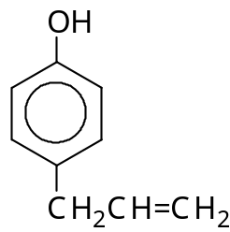  Q  O  H  CH₂CH=CH₂  OR  - P undergoes electrophilic substituition as it decolourises aqueous bromine to form white ppt R. R is 2,4,6-tribromophenol as -OH is a highly activating group.  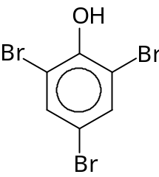  - Q react with aqueous bromine to form white ppt S, with the same no of bromine atoms per molecule of R. As Q has a C-C double bond, electrophilic addition takes place as well. This implies that 1 Br will be attached to one of the carbons of the C-C double bonds. Thus, only 2 Br will be attached directly to the benzene.  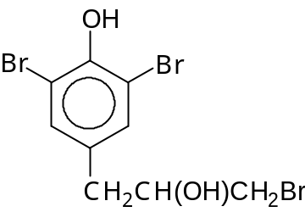  - S  S is optically active because of its chiral carbon. The mirror image of S is non-superimposable.
 |  | (ii) | - Electrophilic Substitution  - • Mechanism  Step 1: Generation of electrophile  CH₂=CHCH₂Cl + AlCl₃ CH₂=CHCH₂⁺ + [AlCl₄]–  Step 2: Electrophilic Attack  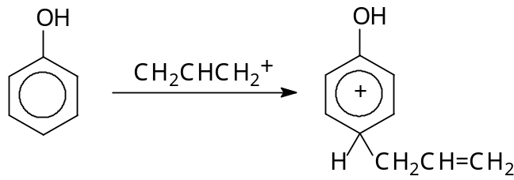  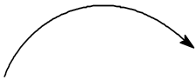  slow  Step 3: Loss of proton  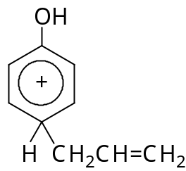    fast  + [AlCl₄]– + HCl + AlCl₃  Any 2 correct steps – Max 1 mark given. 3 correct steps – 2 marks awarded.
 | (c) | - NCl₃ (l) + 3H₂O (l) → NH₃ (aq) + 3HOCl (aq)  - PCl₃ (l) + 3H₂O (l) → H₃PO₃ (aq) + 3HCl (aq)  - Nitrogen is in period 2 and it cannot expand its octet while phosphorus is in period 3 and can expand its octet structure.  - P is able to use its energetically accessible 3d subshell for dative bonding with H₂O in the reaction/accommodate of the lone pair of electrons from H₂O during the nucleophilic attack of H₂O on PCl₃.
 | (d) | (i) | - K_{sp} = [Pb²⁺][ CrO₄ ²⁻]  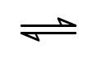  Let the solubility of PbCrO₄ be x mol dm⁻³  PbCrO₄ (s) Pb²⁺ (aq) + CrO₄²⁻ (aq)  - K_{sp} = [Pb²⁺][ CrO₄ ²⁻]  1.69 × 10⁻¹⁴ = x²  x = 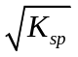  - = 1.30 x 10⁻⁷ mol dm⁻³  The solubility of PbCrO₄ is 1.30 x 10⁻⁷ mol dm⁻³.
 |  | (ii) | - [Pb²⁺] =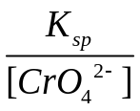 = 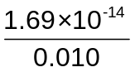  - = 1.69 x 10⁻¹² mol dm⁻³
2 | (a) | Order with respect to E = 1  Comparing experiment 1 and 3  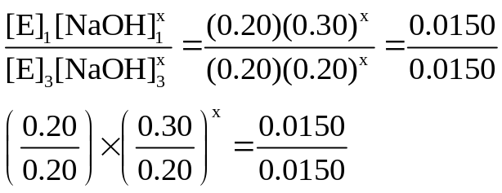  OR When [E] is constant but [OH⁻] is decreased by 1/3 the rate remains the same  • x = 0  Order with respect to F = 1  Comparing experiment 2 and 3  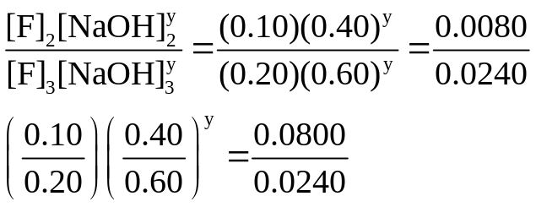  • y = 1
 | (b) | (i)  No. of molecules  E_{a} activation energy  Energy  No. of reactant molecules with energy ≥ E_{a} at 120ºC  No. of reactant molecules with energy ≥ E_{a} at 90ºC | - When the temperature of the reaction increases (pressure remaining the same), the reactant particles gain more kinetic energy and hence move about more rapidly. There is a greater frequency of collision between reactant particles and more reactant particles have energy greater than or equal to the activation energy.  - There are more effective collisions between reactant particles giving rise to an increase in the rate of reaction.
 |  | (ii) | - When the pressure of the reaction increases (temperature remaining the same), the rate of reaction remains the same as the reactants are in the aqueous state and are not affected by pressure. Only the rate of reaction for gaseous reactants are affected by changes in pressure.
 | (c) | (i) | - Compound F is optically active ➔ Compound F has at least one chiral centre, no plane of symmetry and non-superimposable mirror images.  - Compounds E & F do not react with Na metal ➔ Both Compounds E & F do not have –OH groups ➔ Compounds E & F are not alcohols  - Compounds E & F give a positive Tollens’ Test ➔ Compounds E & F are both aldehydes  - E undergoes nucleophilic substitution with NaOH to form G. Since the reaction is first order with respect to E but zero order with respect to NaOH ➔ The reaction is an S_{N}1 reaction  - ➔ E is likely to be a tertiary halogenoalkane and G is a tertiary alcohol  - F undergoes electrophilic substitution with NaOH to form H. Since the reaction is first order with respect to F and with respect to NaOH ➔ The reaction is an S_{N}2 reaction  - ➔ F is like to be a primary halogenoalkane and H a primary alcohol  - E is 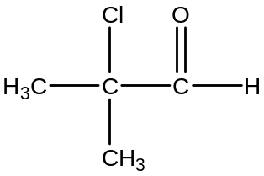  • F is 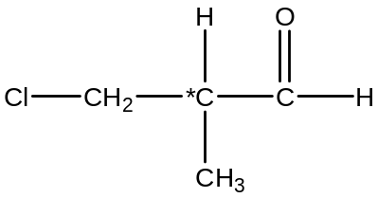  • G is 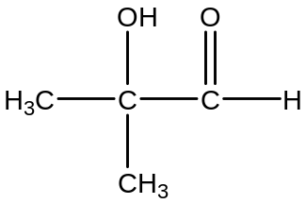  • H is 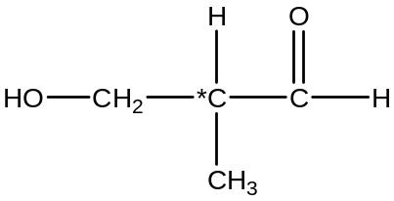  [
 |  | (ii) | 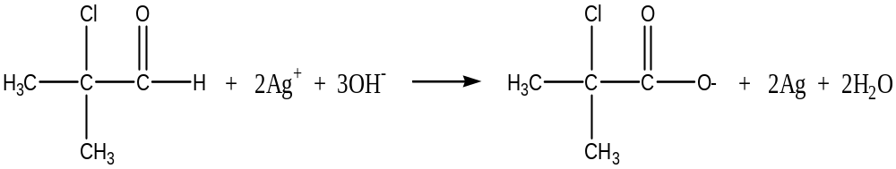
 | (d) | - Mechanism: S_{N}2 nucleophilic substitution  ••  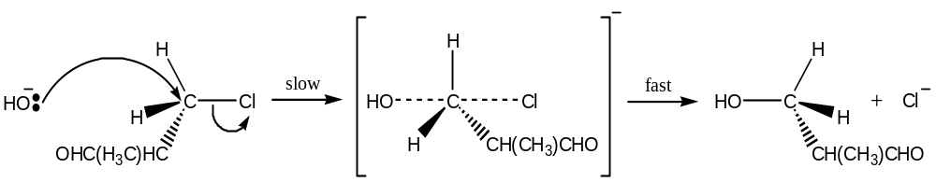  δ+  δ–
3 | (a) | (i) | At the surface of the sea, pressure of CO₂ is 1 atm (normal atmospheric pressure)  •  At 300 m below sea level, the pressure of CO₂ = 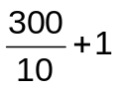  = 31 atm  • Solubility of CO₂ 300 m below sea level  = 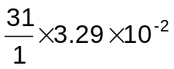  = 1.02 mol dm⁻³
 |  | (ii)  (I) | • [H⁺] = 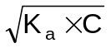  = 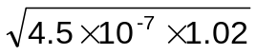  = 6.77 x 10⁻⁴ mol dm⁻³  • pH = -lg(6.77 x 10⁻⁴)  = 3.17
 |  | (II) | • 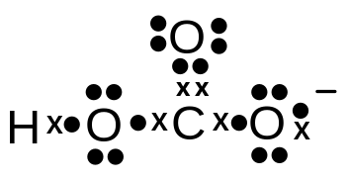
 |  | (III) | • Trigonal planar
 |  | (iii)  (I) | • K_{a2} = 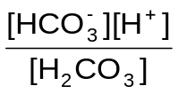
 |  | (II) | K_{a1} = 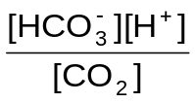  = 4.5 x 10⁻⁷ mol dm⁻³  K_{a2} =  • = 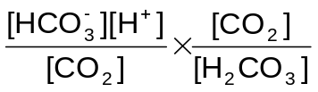  = 4.5 x 10⁻⁷ x 400  • = 1.80 x 10⁻⁴ mol dm⁻³
 |  | (III) | 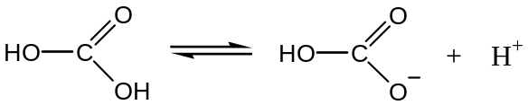  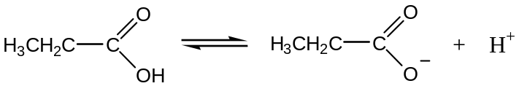  - –OH group on the HCO₃⁻ ion is electron withdrawing and decreases the negative charge density on the COO⁻ group making the ion more stable.  - However CH₃CH₂– group on the CH₃CH₂CO₂⁻ ion is electron releasing and increases the negative charge density on the COO⁻ group making the ion less stable.  H₂CO₃ thus dissociates more readily to form the more stable HCO₃⁻ ion, causing it to be a stronger acid.
 | (b) | (i) | •• dilute HCl or dilute H₂SO₄ , reflux  NaOH(aq) , reflux
 |  | (ii) | ••  In acid hydrolysis  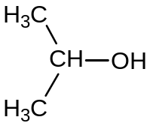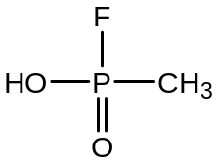  and  OR  In alkaline hydrolysis  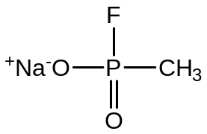  and
 |  | (iii) | - Less resistant  - P-O bond length is longer than C-O, lower bond energy and easier to break OR  P is more susceptible to nucleophilic attack due to the highly electronegative F.
 |  | (iv) | - Carbon, being a period 2 element does not have energetically accessible vacant d-orbitals to allow it to expand its octet structure and accommodate the electrons from fluorine.
 |  | (v) | •• Any 2 of the following structures  (CH₃O)PCl₂ OR  (CH₃O)₂PCl OR  (CH₃O)P(Cl)(OH) OR  (CH₃O)P(OH)₂ OR  (CH₃O)₃P OR  P(Cl₂)(OH) OR  P(OH)₃
4 | (a) | (i) | MgO (s) + 2HNO₃ (aq) → Mg(NO₃)₂ (aq) + H₂O (l)  Amount of MgO = 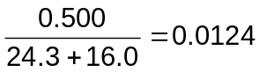mol  - Amount of HNO₃ = 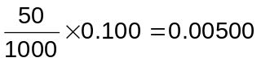mol (limiting reagent)  - Amount of Mg(NO₃)₂ produced = 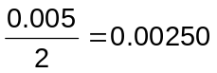mol
 |  | (ii) | Mg(OH)₂ + 2NH₄NO₃ → Mg(NO₃)₂ + 2NH₃ + 2H₂O  - Amount of Mg(NO₃)₂ = 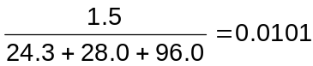mol  - Volume of NH₃ produced = 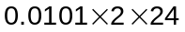= 0.485 dm³
 |  | (iii) | •  2Mg(NO₃)₂ → 2MgO + 4NO₂ + O₂  Brown gas of NO₂ will be observed.
 |  | (iv) | - Ba(NO₃)₂ is more thermally stable than Mg(NO₃)₂, hence it will not decompose at 330°C.  - Ba²⁺ is less polarizing / lower charge density than Mg²⁺ as it has a larger size, hence the NO₃⁻ is polarised to a smaller extent in Ba(NO₃)₂.
 | (b) | (i) | ΔG = ΔH – TΔS  ΔH = ΔG + TΔS  = (-473) + 298(-180/1000)  - = -526.6 kJ mol⁻¹  ΔH_{r} = ΔH_{f}(products) - ΔH_{f}(reactants)  -526.6 = 3(+ 85) + 7(- 286) + 2(- 124) - ΔH_{f}(reactants)  ΔH_{r}(reactants) = - 1468.4 kJ mol⁻¹  - y = - 1468.4 / 4 = - 367.1
 |  | (ii) | - At high temperature, the positive –TΔS eventually outweighs negative ΔH, and so ΔG = ΔH – TΔS becomes positive. (At high temperature, the reaction will be not spontaneous/feasible)
 | (c) | (i) | - Li⁺ cation is small in size and highly polarising in nature / has high charge density / has similar charge density to Mg²⁺. It polarises the CO₃²⁻ anion to a greater extent than other Group I metals allowing it to be decomposed into the oxide and CO₂ like the Group II metals.
 |  | (ii) | - Nucleophilic addition
 |  | (iii) | CH₃CH₂CHBrCH₃ CH₃CH₂C(CH₃)(OH)CH₃  CH₃CH₂CH(OH)CH₃  NaOH(aq),  reflux  CH₃CH₂COCH₃  CH₃ −Li, H₂O  Acidified KMnO₄, reflux  3m for reagents and conditions, 2m for intermediates.
 |  | (iv) | CH₃CH₂CH₂CH₂OH CH₃CH₂CHBrCH₃  Excess concentrated H₂SO₄, 180 ºC  HBr(g) or HBr dissolved in CCl₄  (in the dark)  CH₃CH₂CH=CH₂  2m for reagents and conditions, 1m for intermediate.
5 | (a) | (i) | - Mn is a transition element which forms Mn²⁺ in which the d subshell is partially filled with 5 electrons.  - Water molecule is a ligand and has a lone pair of electrons on O atom that can form a dative bond with the central metal ion Mn²⁺.
 |  | (ii) | - When the ligands approach the central metal ion, splitting of the d-orbitals occur. The energy gap, ΔE between the non-degenerate orbitals corresponds to the wavelength of light in the visible region of the electromagnetic spectrum.  - When d-d transition of electrons takes place, radiation in the visible region of the electromagnetic spectrum corresponding to ΔE is absorbed.  - The light energy not absorbed will be seen as the colour of the complex.
 | (b) | (i) | - Empirical formula of A = MnO₂
 |  | (ii) | - B = MnO₄⁻  - It is a disproportionation reaction  - 3 MnO₄²⁻ + 2H₂O → 2 MnO₄⁻ + MnO₂ + 4OH⁻
 | (c) | (i) | - 5Fe²⁺ ≡ MnO₄⁻  - no. of moles of MnO₄⁻ = 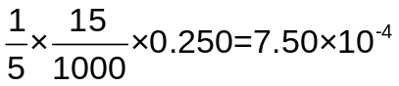mol
 |  | (ii) | - 2MnO₄⁻ + 5H₂O₂ + 6H⁺ → 2Mn²⁺ + 5O₂ + 8H₂O
 |  | (iii) | - no. of moles of MnO₄⁻ reacted with H₂O₂ = 3.00 x 10⁻³ – 7.50 x 10⁻⁴  = 2.25 x 10⁻³ mol  5H₂O₂ ≡ 2MnO₄⁻  • no. of moles of H₂O₂ = 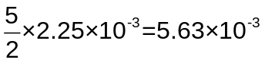mol  mass of H₂O₂ = g  • percentage by mass of H₂O₂ in sample = 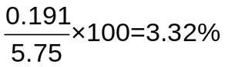
 |  | (iv) | - no. of moles of O₂ produced = 5.63 x 10⁻³ mol  - volume of O₂ produced = 5.63 x 10⁻³ x 24 = 0.135 dm³
 |  | (v) | - Number of moles of silver produced = 1.08 / 108 = 1.00 × 10⁻² mol  Since Ag ≡ e, number of moles of electrons transferred = 1.00 × 10⁻² mol  - Q = I × time = n × F  10 × (t × 60) = 1.00 × 10⁻² × 96500  t = 1.61 min  Number of moles of manganese produced = 0.183 / 54.9  = 0.00333 mol  Mn^{x+} + xe → Mn  - 0 × 10⁻² mol of electrons liberated 0.00333 moles of Mn  x mol of electrons liberated one mole of Mn.  - therefore x = 1.00 × 10⁻² / 0.00333  = 3

